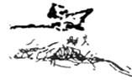
Loudoun Ballet Company
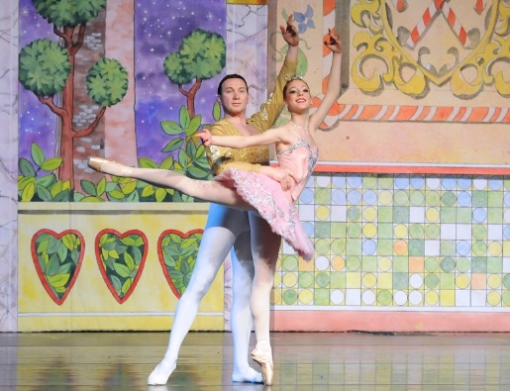
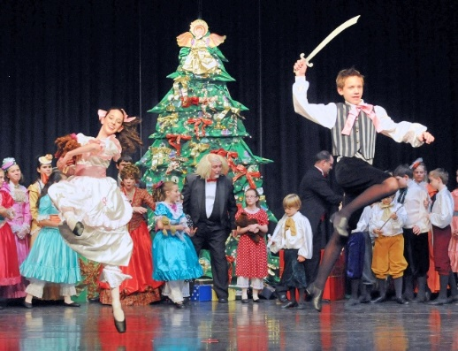
NUTCRACKER OPEN AUDITIONS

Sunday, September 24, 2017

Studio Bleu Dance Center

20660 Ashburn Road

Ashburn, VA 20147

$10 Individual Audition Fee
$20 Audition Fee maximum for families
ONLINE PRE-REGISTRATION
A link to the registration will be sent by email and is available on our Facebook page

Audition Schedule:
Please arrive 15‐20 minutes prior to audition time to complete registration.
Time | Level | Roles
1:00-1:30 PM | Male dancers ages 5-18 | Little Boy Party Guest, Soldier, Toddler, Crown Bearer, Page, Fritz, Adolescent Party Guests
130-1:45 PM | Female dancers age 5-6 (grade K) | 12 possible roles: 7 Gift Bearers, 2 Pages, 2 Babies
1:45-2:00 PM | Female dancers age 6-7 (1st grade) | 8 Bonbons
2:00-2:15PM | Female dancers age 7-8 (2nd grade) | 12 Little Mice, 2 Toddler Girls
2:15-2:30 PM | Female dancers age 8-9 (3rd grade) | 7 Little Angels, 10 Big Angels
2:30-2:45 PM | Female dancers age 9-10 (4th grade) | 12 Snowflurries
2:45-3:15 PM | Female dancers age 10-11 (5th grade) | 6 Little Girl Party Guests, 2 Maids
3:30-4:15 PM | Female dancers age 11-13 (6th and 7th grades) | 12 Soldiers, 8 Flower Corps, 4 Little Tea, 4 Candy Cane Corps
4:15-5:00 PM | Female dancers 13&up | 6 Adolescent Party Guests, 12 Big Mice, and others
Adults – Audition not necessary. Please contact Ken Davenport via email (kdavenport@loudounballet.org)
to express an interest.
Boys – Open audition for boys age 5 and up.
Audition attire: Shorts or sweatpants, white tee shirts
Girls – Open audition for age 5 thru 18 currently taking ballet classes.
Audition attire: Classic leotard, tights, ballet slippers, hair in bun

