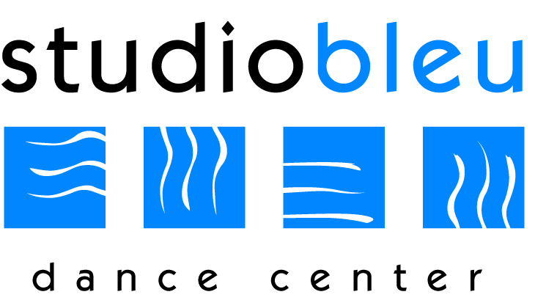
Studio Bleu Dance Center
IMPORTANT DATES
2019-2020
September: 3rd First Day of Classes and Tuition Due
October: 7th-12th Bring a Friend to Dance Week
24th-30th Halloween Costume Week
31st STUDIO CLOSED - Halloween
November: 1st Tuition Due and Recital Costume Payment Due
25th-30th STUDIO CLOSED – Thanksgiving Break
December: 16th-21st Parent Observation Week
23rd – Jan. 4th STUDIO CLOSED – Winter Break
January: 1st Tuition Due
6th Classes Resume
13th-18th Bring a Friend to Dance Week
20th STUDIO CLOSED - Martin Luther King, Jr. Day
February: 17th STUDIO CLOSED – President’s Day
March: 1st Tuition Due
16th-21st Parent Observation Week
April: 6th-11th STUDIO CLOSED – Spring Break
26th Recital Ticket Sales & Open House
May: 1st Tuition Due
22nd-25th STUDIO CLOSED – Memorial Day Weekend Break
31st Recital Picture Day & Dress Rehearsal (Tentative)
June: 4th Last Day of Classes
5th-6th Recital (Tentative)
HOW TO CONTACT US!
SBDC: 703.729.9293 Email: studiobleudancecenter@gmail.com
Website: www.danceashburn.com For Closings go to: NBC 4/ Studio Voicemail
Join Us on Facebook: Studio Bleu Dance Center Instagram and Twitter: @studiobleudc

