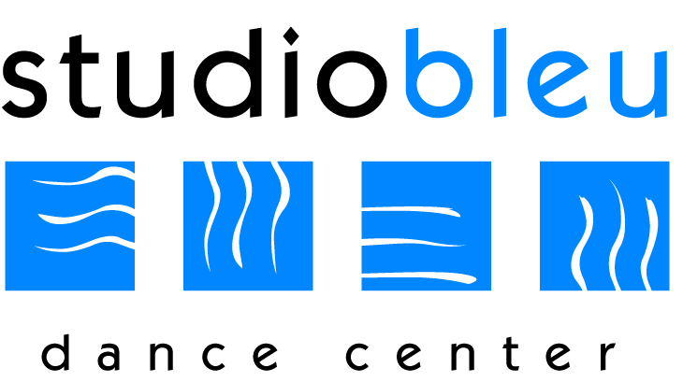
Studio Bleu Dance Center
IMPORTANT DATES
2017-2018
September: 5th First Day of Classes and Tuition Due
October: 2nd-7th Bring a Friend to Dance Week
24th-30th Halloween Costume Week
31st STUDIO CLOSED- Halloween
November: 1st Tuition Due and Recital Costume Payment Due
20th-25th STUDIO CLOSED – Thanksgiving Break
December: 11th-16th Parent Observation Week
18th – Jan. 1st STUDIO CLOSED – Winter Break
January: 1st Tuition Due
2nd Classes Resume
8th-13th Bring a Friend to Dance Week
15th STUDIO CLOSED - Martin Luther King, Jr. Day
February: 19th STUDIO CLOSED – President’s Day
March: 1st Tuition Due
19th-24th Parent Observation Week
26th-31st STUDIO CLOSED – Spring Break
April: 29th Recital Ticket Sales & Open House
May: 1st Tuition Due
25th-28th STUDIO CLOSED – Memorial Day Weekend Break
June: 3rd Recital Picture Day/Recital Dress Rehearsal (tentative)
7th Last Day of Classes
8th-9th Recital (tentative)
HOW TO CONTACT US!
SBDC: 703.729.9293 Email: studiobleudancecenter@gmail.com
Website: www.danceashburn.com For Closings go to: NBC 4/ Studio Voicemail
Join Us on Facebook: Studio Bleu Dance Center Instagram and Twitter: @studiobleudc

