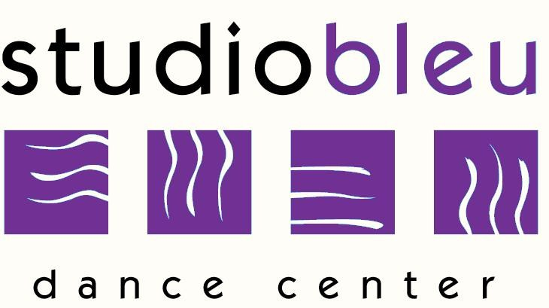

Fall 2019-2020
Private Lesson Request Form

We are now accepting requests for privates (solos, duos, and/or trios) for the fall. Please fill out a form for each request and return to the front desk.
Solo, duo, or trio slots for the fall season are on a first come, first serve basis. The time slots will be assigned within the first week of the fall session and will run from September 2019 to June 2020. Make Up lessons can be made for privates only when advanced notice is given that the dancer(s) will miss a practice.

Name:____________________________________________________ Date: ___________

Age: ___________ Dance Discipline: __________________________________________

Requested Teacher: ________________________________________________________

Requested Day/Times: ______________________________________________________

____________________________________________________________________________

____________________________________________________________________________

Parent Signature: ___________________________________________________________
*Privates will be charged September 2019-June 2020. All choreography taught at SBDC is the sole possession of SBDC and cannot be used outside the studio without permission from the management.

Phone Number: _____________________________________________________________

E-mail Address: _____________________________________________________________

Payment:

Circle One: Cash Credit Card (VISA/MC or DISCOVER) Check

Total Payment:_________________ Check #________________

CC#:________________________________________________ Exp. Date______________

