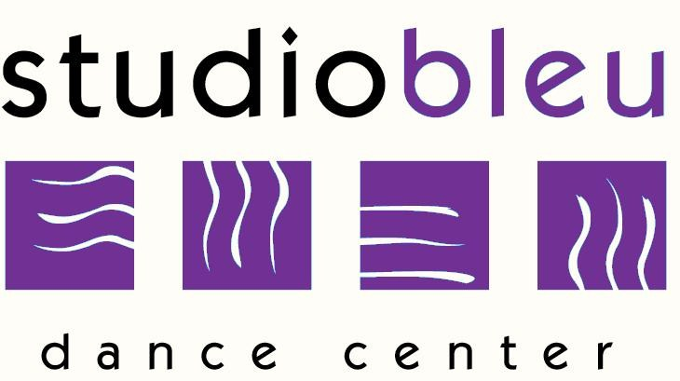
Studio Bleu Dance Center
Tuition Schedule

September 2019-June 2020

Registration Fees
Returning Students: $25
New Students: $30

Hours Per Week Bi-Monthly* Yearly Tuition*
(*Every 2 months)
1 $156.00 $780.00
2 $276.00 $1,380.00
3 $376.00 $1,880.00
4 $476.00 $2,380.00
5 $556.00 $2,780.00
6 $646.00 $3,230.00
Unlimited Classes $726.00 $3,630.00

Private Solo
30 Minutes $350.00 $1,750.00

Private Duo (per person)
30 Minutes $206.00 $1,030.00

Private Trio (per person)
30 Minutes $158.00 $790.00

Tuition is based on a yearly fee, September-June, divided into 5 equal payments. Tuition is due by the 1st of September, November, January, March, and May. A $25 late fee will be assessed on the 10th of November, January, March, and May for any unpaid tuition.

*Tuition paid in full for the year will receive a 5% discount. Tuition must be paid by check or cash only no later than September 2019. (Tuition paid in full is non-refundable).

