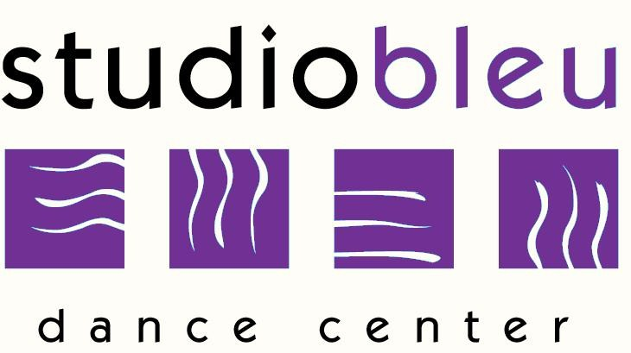
Studio Bleu Dance Center
Tuition Schedule

September 2017-June 2018

Registration Fees
Returning Students: $25
New Students: $30

Hours Per Week Bi-Monthly* Yearly Tuition*
(*Every 2 months)
1 $150.00 $750.00
2 $270.00 $1,350.00
3 $370.00 $1,850.00
4 $470.00 $2,350.00
5 $550.00 $2,750.00
6 $640.00 $3,200.00
Unlimited Classes $730.00 $3,650.00

Private Solo
30 Minutes $350.00 $1,750.00

Private Duo (per person)
30 Minutes $206.00 $1,030.00

Private Trio (per person)
30 Minutes $158.00 $790.00

Private Quartet or Group (per person)
30 Minutes $142.00 $710.00

Solo, Duo, Trio Choreography Only: $650.00
Includes 6 hours of choreography instruction. Times to be scheduled with individual choreographer. Dancer(s) will not receive weekly instruction, and will be running the dance on their own if they do choreography only.

Guest Artist Choreography: Dependent on Artist
Groups, Soloists, etc chosen to work with outside guest choreographer’s, not part of Studio Bleu’s Staff, may incur one-time choreography fees. These fees will be determined based on the individual Choreographer’s rate, hours required, number of dancers involved, etc.

Tuition is based on a yearly fee, September-June, divided into 5 equal payments. Tuition is due by the 1st of September, November, January, March, and May. A $25 late fee will be assessed on the 10th of November, January, March, and May for any unpaid tuition.

*Tuition paid in full for the year will receive a 5% discount. Tuition must be paid by check or cash only no later than September 2017. (Tuition paid in full is non-refundable).

